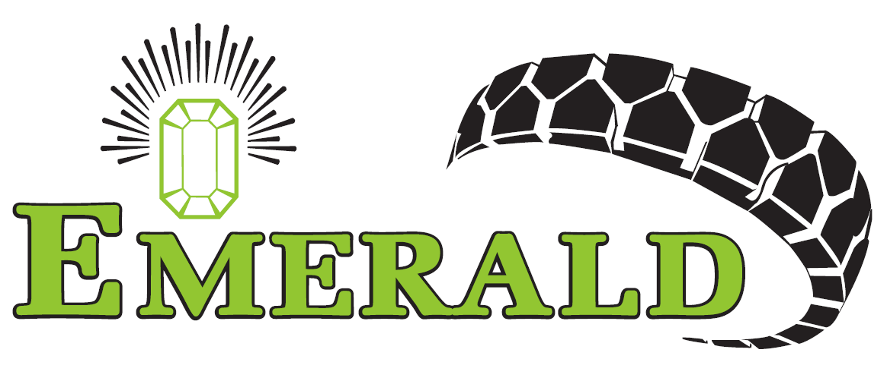 | EMERALD RESILIENT TYRE MANUFACTURERS PVT. LTD.,  79 & 80, Export Promotional Industrial park,  SIPCOT Industrial complex,  Gummidipoondi. | DOC NO : QP/MN/01  ISSUE NO : 01  ISSUE DATE: 16/11/20  PAGE 1 OF 2
QUALITY PROCEDURE MANUAL
MAINTENANCE

- PURPOSE:
The purpose of this procedure is to establish a system for preventive, predictive and breakdown maintenance of equipment and machines to ensure their continuous / smooth function.

- SCOPE:

This procedure is applicable to all the machinery used.

- RESPONSIBILITY:

Maintenance Incharge

- AUTHORITY:

This procedure is approved and authorized by CEO and can be amended only by him.

- DEFINITIONS:

--

- PROCEDURE:

  - Maintenance In charge is responsible to carry out Preventive and Predictive Maintenance of the plant and machinery as per classification.

  - PREVENTIVE MAINTENANCE:

    - Maintenance Incharge as per the relevant checklists do daily maintenance.

    - The maintenance Incharge prepare weekly, Monthly and annual preventive maintenance schedule.

    - Maintenance Incharge as per the maintenance schedule and relevant checklists carry out weekly, monthly and annual maintenance.

    - Records of preventive maintenance are maintained.

PREPARED BY  DEPT HEAD | APPROVED BY  CEO & JMD | ISSUED BY  Management Representative | REVISION NO: 0  REVISION DATE: --

 | EMERALD RESILIENT TYRE MANUFACTURERS PVT. LTD.,  79 & 80, Export Promotional Industrial park,  SIPCOT Industrial complex,  Gummidipoondi. | DOC NO : QP/MN/01  ISSUE NO : 01  ISSUE DATE: 16/11/20  PAGE 2 OF 2
QUALITY PROCEDURE MANUAL
MAINTENANCE

  - PREDICTIVE MAINTENANCE:

    - The Maintenance technician assesses the working of important process equipment and machines during their usage.

    - Any abnormality monitored is analyzed and then the required maintenance is done or considered for incorporating in the preventive maintenance schedule.

    - Records of predictive maintenance are maintained.

  - BREAKDOWN MAINTENANCE:

    - In case of any breakdown, a maintenance requisition is made in the MAINTWIZ (mobile / PC), application/software to register the breakdown. Shift supervisor/ concerned operator can initiate the request, the request will reach the shift maintenance in charge/technician.
    - The analysis of the breakdown is carried based on the information from the Maintwiz app and scrutinization of issue from the machine, the technician does necessary maintenance.
    - After repairs the machine is checked for its smooth operation by technician/supervisor, and observation recorded in the Maintwiz app.
    - The frequency of breakdown of the equipment is reviewed and schedule for preventive maintenance is revised in case of the breakdown frequency is high.
    - The maintenance In-charge maintains equipment history record.

  - The effectiveness of corrective actions are verified through results/trend graphs as applicable

- RECORDS:

Preventive Maintenance schedules.(FT/MN/03
Machine history record(FT/MN/02)
Daily log sheet – Boiler (FT/MN/09)

- REFERENCE:

Maintenance checklist.

PREPARED BY  DEPT HEAD | APPROVED BY  CEO & JMD | ISSUED BY  Management Representative | REVISION NO: 01  REVISION DATE: 03.02.21

